Life at Home During the War
Taken from the Canadian War Museum

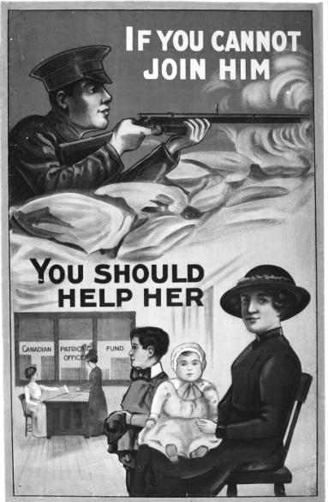
Government Intervention
The war expanded the range and complexity of government activity and increased governmental involvement in many aspects of Canadian life. Canada entered the war with a small public service, no income tax, and few forms of direct government involvement in the economy. The federal government had no experience in running a large war and assumed, as did most Canadians, that a “business as usual” attitude would suffice in organizing the country for the struggles ahead.
But the war cost vast amounts of money, demanded enormous supplies of people, goods, and services, and placed great stress on wages, prices, and many areas of home front activity. In mobilizing support for the war abroad while attempting to ease or manage its effects at home, the federal government became increasingly involved in the lives of Canadians, usually with great reluctance and not always with success.

Food, Fuel, and Inflation
The war pulled Canada from a two-year economic depression by boosting economic activity and reducing unemployment. It also strained the country’s fragile, resource-based economy and its mostly unregulated industries. Wage and price inflation, scarcity, profiteering, and labour shortages led to growing efforts by government to manage resources in support of the war.
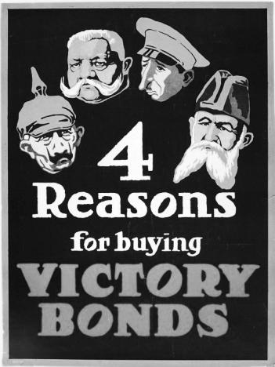
Government at first appealed to voluntary efforts. It asked the public to reduce the consumption of scarce commodities, including fuel, to produce more food, and not to hoard essential items. In most cases, it avoided trying to set prices or regulate commercial activity.
Rising prices for Canadian commodities such as wheat were good for farmers and exporters, but inflation eroded the purchasing power of many families. In busy, fast-growing cities energized by war employment, prices rose faster than wages, leading to labour unrest and strikes. Inflation posed special hardships for people on fixed incomes or those who did not benefit from the competition for skilled workers. Women living at home on the fixed salaries of soldier-husbands overseas often faced difficult social choices: a lower living standard; or entry into the growing paid labour force and daycare for their children.
In the summer of 1917, Ottawa resorted to more direct efforts, appointing food and fuel controllers to encourage production, avoid waste, and manage shortages.
A new Board of Grain Supervisors coordinated bulk sales of the West’s most important product, wheat, at high fixed prices to European markets. By early 1918, the new Canada Food Board licensed and monitored food sales in public establishments and encouraged food or ingredient substitutes for high-demand items. Propaganda posters urged “fuel-less Sundays”, “meatless Fridays”, and the elimination of wasteful shopping and cooking practices. Newspapers published special “war menus”. Provinces and municipalities managed local hydro and power shortages, sometimes by short-term closures in schools and factories.
These measures represented more government coordination and control than Canadians had ever experienced. Many of them proved temporary, ending in either 1918 or 1919, but in some areas, such as taxation, social welfare, and the responsibility for veterans, the state assumed powers it would never again relinquish.

Enemy Aliens
The early part of the war witnessed a substantial backlash against many elements of the German presence in Canada. Public schools removed German language instruction from their curricula. Some orchestras refused to play German music. Winnipeg residents changed hamburgers to “nips” in order to sever the association with an enemy language. The sinking of the civilian liner Lusitania in 1915 with hundreds of civilian deaths seemed to confirm the popular view that Canada fought in a singularly noble cause against a nation of barbarians. Ugly riots in Victoria, Winnipeg, and Montreal targeted German-owned businesses and shops.
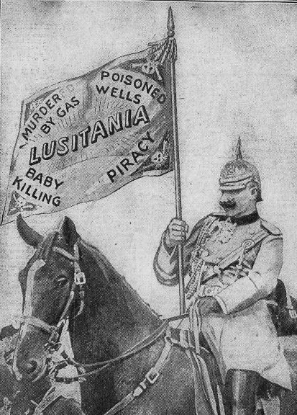
From the start of the war, most Canadians demonized the enemy. They believed the stories and rumours from overseas concerning German war crimes, and accepted without question what would mainly prove to be fabricated reports of German atrocities in Belgium, especially those involving women and children. News of heavy casualties and the use of a heinous new weapon, poison gas, at the Battle of Second Ypres in April 1915, galvanized public opinion against Germany and further convinced Canadians of the enemy’s fundamental barbarity. War propaganda reinforced enemy stereotypes and intentionally blurred the line between actual news and useful innuendo.
Wartime propaganda soon referred to German Kultur (culture) as a damning insult, a predisposition for war, cruelty, and destructiveness that placed Germany outside the community of civilized nations. A total effort against such an enemy was more than justified, the imagery screamed: it was expected.
Anti-German propaganda, stories of German atrocities abroad, and fear of saboteurs drove many Canadians to demand protection from their government. At the outset of war in August 1914, the Canadian government quickly enacted the federal War Measures Act (WMA). The Act’s sweeping powers permitted the government to suspend or limit civil liberties in the interest of Canada’s protection, including the right to incarcerate “enemy aliens”.
The term “enemy alien” referred to the citizens of states legally at war with Canada who resided in Canada during the war. Under the authority of the WMA, Canada interned 8,579 enemy aliens in 24 receiving stations and internment camps from 1914-1920. Otter classified 3,138 as prisoners of war, while the others were civilians. The majority of those interned were of Ukrainian descent, targeted because Ukraine was then split between Russia (an ally) and the Austro-Hungarian Empire, an enemy of the British Empire. In addition to those placed in camps, another 80,000 enemy aliens, again mostly Ukrainians, were forced to carry identity papers and to report regularly to local police offices.
The government frequently employed internees on massive labour projects, including the development of Banff National Park and numerous mining and logging operations. Sir William D. Otter, one of Canada’s pre-eminent soldiers, commanded the operation of these often rural and remote internment camps. Internees had much of their wealth confiscated, although most were paid .25 a day, far less than that offered to labourers of the time period. Interned Canadians were also disenfranchised during the course of the war.
War-time fervour and xenophobic fear had been the main factors driving the policy of internment, and not actual attacks on Canada’s domestic war effort by enemy sympathizers. There were a few inept plans for sabotage on Canadian soil, and fear of a German invasion persisted for several years, but no serious threats materialized.

The War Economy
Like most other combatants in 1914, Canadians expected the war to be short, victorious, and relatively inexpensive. They were wrong; the war did not end quickly. The effort required to sustain massive armies in the field rescued the Canadian economy from recession. It also required huge amounts of capital. A pre-war federal budget of $185 million had quadrupled by its wartime peak to more than $740 million. Debt quadrupled to $1.2 billion as well. Prior to the war, customs duties, postal rates, and tariffs on imported goods had accounted for more than 85 per cent of government revenue. Higher duties and new tariffs alone could not hope to cover vastly higher wartime expenditures. Ottawa borrowed to finance the shortfall from an unexpected source: ordinary Canadians.
Canadians’ willingness to loan money to their own government by buying war bonds exceeded all expectations. No bond issue in Canadian history had raised more than $5 million, but Ottawa’s first “victory bond” drive brought in $100 million, twice the initial estimate. Subsequent drives proved just as successful. Publicity campaigns, including tens of thousands of posters, linked buying bonds to the direct support and welfare of soldiers overseas and used a variety of messages to encourage contributions, from well-known poems to emotional imagery. Long-term interest rates of up to 5.5 per cent for terms of up to 20 years were also a powerful inducement.
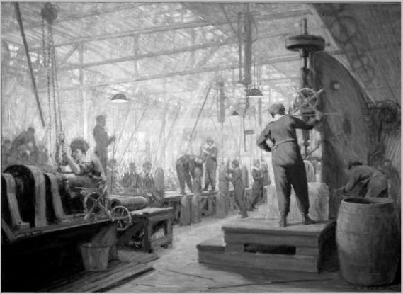
Total domestic bond purchases during the war exceeded $2 billion, ten times the amount of money raised abroad. Canada had financed the war by incurring more than $2 billion in debt, thereby passing the war’s costs to future generations, but it owed most of this money to Canadian citizens, not foreign lenders.
The outbreak of war threatened Canada with economic crisis. Existing manufacturing orders were cancelled, some factories shut down, and construction halted on many pre-war civilian projects. Some feared that war would cause the collapse of Canada’s already fragile economy. But the demand for war supplies, equipment, and shells soon provided economic stimulus and employment. Output grew and fears of collapse were replaced by the challenges of rapid expansion. Due to the combined demands of military service, industry, and agriculture, unemployment had virtually ceased in Canada by 1916.
One of the greatest economic surprises of the war was the military’s near-insatiable demand for vast quantities of artillery shells. Armies expended them by the millions in the great barrages and siege-like battles on the Western front, and no Allied economy was organized to produce shells in anything near the quantities required.
Canada’s Minister of Militia and Defence, Sam Hughes, initially established a Shell Committee to coordinate production, but its failure to deliver on contracts led to angry recriminations between Canada and Britain and widespread rumours of corruption.
In late 1915, Prime Minister Borden replaced the Shell Committee with the Imperial Munitions Board (IMB), which answered solely to Britain but was run by a Canadian. Under well-known Toronto businessman Joseph Flavelle, the Board was organized according to sound business practices and hired professional managers to oversee its operations. It eased the problem of scarce labour by hiring 30,000 women to work in its factories and offices.
Under Flavelle’s supervision, the Board oversaw an impressive expansion in wartime production, from only a few companies having the capacity to produce shells to, in 1917, dozens of companies, including crown corporations, that collectively produced some $2 million worth of goods per day.
The IMB’s mandate later expanded to include propellants, brass casings, and complicated fuses. By 1917, almost one-third of all British shells were being manufactured in Canada. The IMB constructed ships and aircraft and developed airfields for a large pilot training program. By war’s end, its 600 factories had completed some 103 naval vessels, 2,600 training aircraft, and 30 flying boats. When the IMB ceased operations in 1919, it was Canada’s largest civilian employer, with over 289,000 employees.

Farming and Food
Food production and agriculture were essential parts of Canada’s war effort, and Ottawa encouraged farmers and food processors to maximize their output.
Agricultural production grew rapidly in response to federal urging, international scarcity, and high prices. Rural families grew wealthier as exports of wheat, cheese, meat, fish, and other staples rose in the face of rising international demand. But soaring profits hid serious problems, especially on the wheat-producing Prairies, where heat, drought, frost, and soil exhaustion during the war reduced output per acre even as the size of farms expanded and demands for farm labour grew.
Farm labour shortages led the authorities to ask older children and adolescents for help. ‘Soldiers of the Soil’ (SOS) was a national initiative run by the Canadian Food Board. It encouraged adolescent boys to volunteer for farm service, and recruited 22,385 young men across the country. Many came from urban high schools and lived on rural farms for terms of three-months or more.
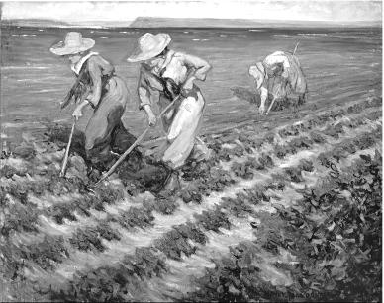
In exchange for their labour, SOS recruits received room and board, spending money, and – in the case of high school students – exemption from classes and final exams. On completion of their term and “honorable discharge,” they also received an SOS badge acknowledging their service, often at a community ceremony.
The labour shortage also led to government and private sector support for the employment of women, and some high school girls and boys, in agriculture. The Farm Service Corps, for example, was an initiative of the Ontario government similar in purpose to the national Soldiers of the Soil program, but aimed mainly at women.
Its “farmerettes” assisted in all aspects of farm work, replacing the labour of men lost to military service. In 1918, for example, 2,400 women picked fruit in the Niagara region. The Young Women’s Christian Association, or YWCA, also ran agricultural work camps, as did some charitable agencies and provincial departments of public works. While there were no formal programs like this in other provinces, rural women contributed extensively to farm work, as they had before the war, but now they often did so without their husbands, sons, or labourers to assist. Despite these challenges, it was this type of lonely, back-breaking labour that helped Canada to supply its Allies with war-winning material and food.

Conscription, 1917
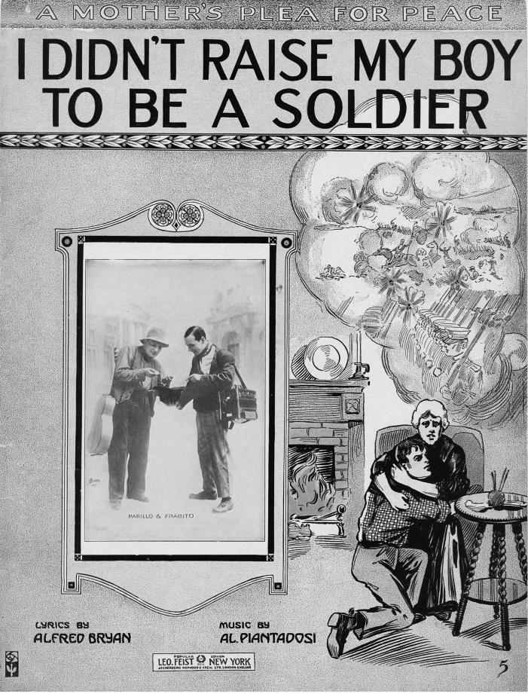
The 1917 conscription debate was one of the fiercest and most divisive in Canadian political history. French-Canadians, as well as many farmers, unionized workers, non-British immigrants, and other Canadians, generally opposed the measure. English-speaking Canadians, led by Prime Minister Borden and senior members of his Cabinet, as well as British immigrants, the families of soldiers, and older Canadians, generally supported it.
The conscription debate echoed public divisions on many other contemporary issues, including language education, agriculture, religion, and the political rights of women and immigrants. It also grew into a test of one’s support for, or opposition to, the war as a whole. Charges of disloyalty, cowardice, and immorality from avid pro-conscription advocates were matched by cries of imperialism, stupidity, and bloodlust by the anti-conscription camp.
The conscription debate raged through most of 1917 and into 1918. The required legislation, the Military Service Act, worked its way through Parliament during the summer to be passed in late August. It made all male citizens between the ages of 20 and 45 subject to military service, if called, for the duration of the war.
Conscription was the main issue in the federal election that followed in December, a bitter contest between Conservative / Unionist Sir Robert Borden and Liberal Sir Wilfrid Laurier. Borden, running on a ‘Unionist’ pro-conscription ticket that attracted many English-speaking Liberals, won decisively, but lost heavily in Francophone areas of Quebec.
The government had helped pave the way for electoral victory with legislation in the fall that enfranchised likely allies and disenfranchised likely opponents.
The Wartime Elections Act gave the vote to the wives, mothers, and sisters of soldiers, the first women permitted to vote in Canadian federal elections. These groups tended to favour conscription because it supported their men in the field.
The Act then denied the vote to many recent immigrants from enemy countries (“enemy aliens”), unless they had a family member in military service. At the same time, the Military Voters Act extended the vote to all military personnel and nurses, including women, regardless of their period of residence in Canada.
A broadly popular but divisive measure, conscription polarized provinces, ethnic and linguistic groups, communities, and families, and had lasting political effects on the country as a whole. For many Canadians, it was an important and necessary contribution to a faltering war effort; for others, it was an oppressive act passed dishonestly by a government more British than Canadian.
Conscription would have minimal impact on Canada’s war effort. By the Armistice in November 1918, only 48,000 conscripts had been sent overseas, half of which ultimately served at the front. More than 50,000 more conscripts remained in Canada. These would have been required had the war continued into 1919.

