CBC-Angus Reid poll: Canadians want minorities to do more to 'fit in'

Majority polled also said immigration policies should put Canada's economic needs first
By Jason Proctor, CBC News Posted: Oct 03, 2016 12:00 AM PT Last Updated: Oct 03, 2016 6:34 AM PT
As a divisive election tears Americans apart over questions of race and immigration, a CBC News poll suggests Canadians are right in believing they think very differently than their U.S. neighbours when it comes to multiculturalism.
In fact, we're more likely to think minorities should assimilate.
In a national polling partnership between CBC and the Angus Reid Institute, 68 per cent of Canadian respondents said minorities should be doing more to fit in with mainstream society instead of keeping their own customs and languages.
The same question was put to Americans, with only 53 per cent of respondents saying minorities need to better adjust.
The Canadian response represents a hardening of attitudes away from multiculturalism over time.
"It does seem like a very surprising finding, especially when you consider this is a country that has been living with 45 years of official multiculturalism as government policy," said Shachi Kurl, executive director of the Angus Reid Institute.
"It is maybe not what conventional wisdom might expect. But what these findings show is there are real limits on what Canadians — regardless of their own heritage or walk of life — are prepared to put up with in terms of accommodation and the sense of the mosaic versus the melting pot."
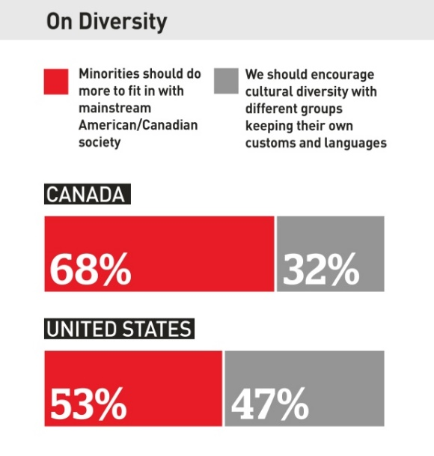

‘Something that bears watching'
The online survey was conducted in early September from a sample of 3,904 Canadians. The results have a 2.5 per cent margin of error 19 times out of 20.
The poll was conducted in the wake of a series of issues that dogged politicians as they contested last year's federal election: a proposed ban on niqabs in public service; the Syrian refugee crisis; and terrorist attacks both in Europe and on Parliament Hill.
The results also hint at why Conservative leadership candidate Kellie Leitch believes she may be onto a winning issue by asking supporters their thoughts on vetting would-be immigrants and refugees for "anti-Canadian values."
According to the poll, two-thirds of Canadians say they're "satisfied" with how well new immigrants are integrating into their communities.

According to the poll, two-thirds of Canadians say they're "satisfied" with how well new immigrants are integrating into their communities. That figure seems to fly in the face of another result, because an equal number said they believe "minorities should do more to fit in better with mainstream Canadian society."
Kurl compared that figure with a similar poll done in 1993 in which 57 per cent of respondents thought minority groups should be encouraged to "try to change to be more like most Canadians."
"It's not a crisis by any means" she said.
"That said, when nearly 70 per cent of people in this country are saying they would like to see minorities do more to fit in, it is something that bears watching, particularly because that view has hardened over the last 25 years."

'Unthinking or mindless multiculturalism'
Former B.C. premier and Liberal cabinet minister Ujjal Dosanjh has written and spoken extensively about the need to address concerns about equality, race and culture in the face of blind devotion to multiculturalism.
He said the poll shows Canada's political leadership needs to pay attention.
"What you want is creative multiculturalism, generous multiculturalism, but not unthinking or mindless multiculturalism where everything anybody brings to this country is acceptable," he said.
"Diversity is great if we can begin to live with each other in equality, in understanding ... but we also understand our collective obligations to building a better society. If we can't live together with each other properly and make concessions to each other, then this phrase that politicians use — that diversity is a strength — is nonsensical."
Dosanjh says he's not surprised the results had a higher percentage of Canadians than Americans indicating they favour better assimilation.
He said the difference may simply come down to the fact that more Americans believe immigrants are integrated anyway, that newcomers and old stock alike are united in the common pursuit of the "American dream."
"Some people may believe it's jingoistic, but the fact is that that's the kind of narrative that can knit people together and bring them together across differences, customs and languages," he said.
"Canada has no such narrative."

Give priority to Canada's 'workforce needs'
The poll says people who have been living in Canada 10 years or less are nearly twice as likely as other respondents to say that minorities should retain their customs, languages and culture.
Millennial respondents — aged 18 to 34 — were also more likely to favour multiculturalism. The shift towards assimilation increased with age.
Likewise, immigrants who have been in the country for more than 20 years are in lockstep with the two-thirds of respondents overall who said minorities should be doing a better job of fitting in.
Participants were also asked about Canada's approach to immigration, particularly after the Liberal government's move to bring in 25,000 refugees from war-torn Syria.
According to the poll, 79 per cent of respondents said Canada's immigration and refugee policies should "give priority to Canada's own economic and workforce needs" rather than giving "priority to people in crisis abroad."
"At the end of the day, we're pretty practical in what we want and what we value in this country," Kurl said.
"I think that's an important reminder for policy-makers. We are an embracing country, we are an accepting, a tolerant country, one that celebrates different cultures. But it doesn't mean we don't have an underlying practicality at play around what we want to be as a country, and how people coming to this country play a role in that."

